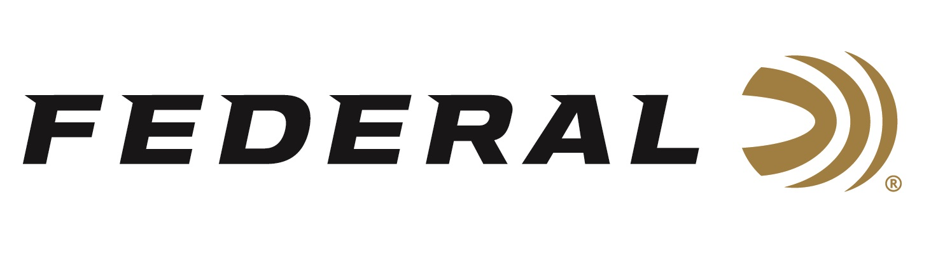

FOR IMMEDIATE RELEASE

Team Federal’s Tomasie Claims Title at Double Tap Championship

ANOKA, Minnesota – May 3, 2022 – Team Federal’s Travis Tomasie won the Limited Division and finished 7th overall at the Double Tap Championship held at the Double Tap Ranch in Wichita Falls, TX. In total, there were 158 shooters competing and the event was administered under the USPSA rule book.

“Travis Tomasie is one of the most respected shooters in the game and is a serious contender to win any match he enters,” said Jason Spradling, Federal’s Shooting Sports Promotions Manager. “Federal is honored to have him on the team and proud that Syntech Action Pistol could be part of his winning performance.”
“The Double Tap is always a great match with terrific staff and both fun and challenging courses of fire,” said Team Federal’s Travis Tomasie. “My Federal Syntech Action Pistol performed flawlessly and provided the accuracy, low felt recoil, and reliability that I demand,” said the High-overall Limited Champion.
Syntech Action Pistol is specifically designed for the action shooting sports and loaded to power factor requirements with heavy, flatter-nosed bullets for more reliable knock-downs on steel targets in competition. For more information on all products from Federal or to shop online, visit www.federalpremium.com.

Press Release Contact: JJ Reich
Senior Manager – Press Relations
E-mail: VistaPressroom@VistaOutdoor.com

About Federal Ammunition
Federal, headquartered in Anoka, MN, is a brand of Vista Outdoor Inc., an outdoor sports and recreation company. From humble beginnings nestled among the lakes and woods of Minnesota, Federal Ammunition has evolved into one of the world's largest producers of sporting ammunition. Beginning in 1922, founding president, Charles L. Horn, paved the way for our success. Today, Federal carries on Horn's vision for quality products and service with the next generation of outdoorsmen and women. We maintain our position as experts in the science of ammunition production. Every day we manufacture products to enhance our customers' shooting experience while partnering with the conservation organizations that protect and support our outdoor heritage. We offer thousands of options in our Federal Premium and Federal® lines-it's what makes us the most complete ammunition company in the business and provides our customers with a choice no matter their pursuit.

